**Solution Overview for hCard Builder Task**

**Problem Statement**: Using HTML, CSS and Javascript code up the hCard builder to the specified design. The preview pane should automatically update to show the content entered in the form. You do not need to build the submit page for the form itself or integrate any back-end technologies.

**Workflow:** The application is based on MVC using angular framework. The data synchronization between the form and preview card is being achieved by using the data-binding. Controllers can be further enhanced to incorporate the validation functionality.

**Technologies used:** The task has been implemented using the following technologies:

* HTML5
* CSS3
* Angular
* Bower
* Jquery
* Javascript

**Testing Environments:** The application runs successfully on following platforms:

* Browsers: Chrome, Firefox, IE

Due to the unavailability of actual testing devices at the moment, the application has been tested on developer tools.

**How to run:**

1. Download the zip folder.
2. Unzip via Winrar application in convenient location.
3. Locate ‘hCard Builder.html’ file inside ‘app’ folder.
4. Run ‘hCard Builder.html’ file in any browser.

**Screen Shot:**

1. Data entry with Preview:

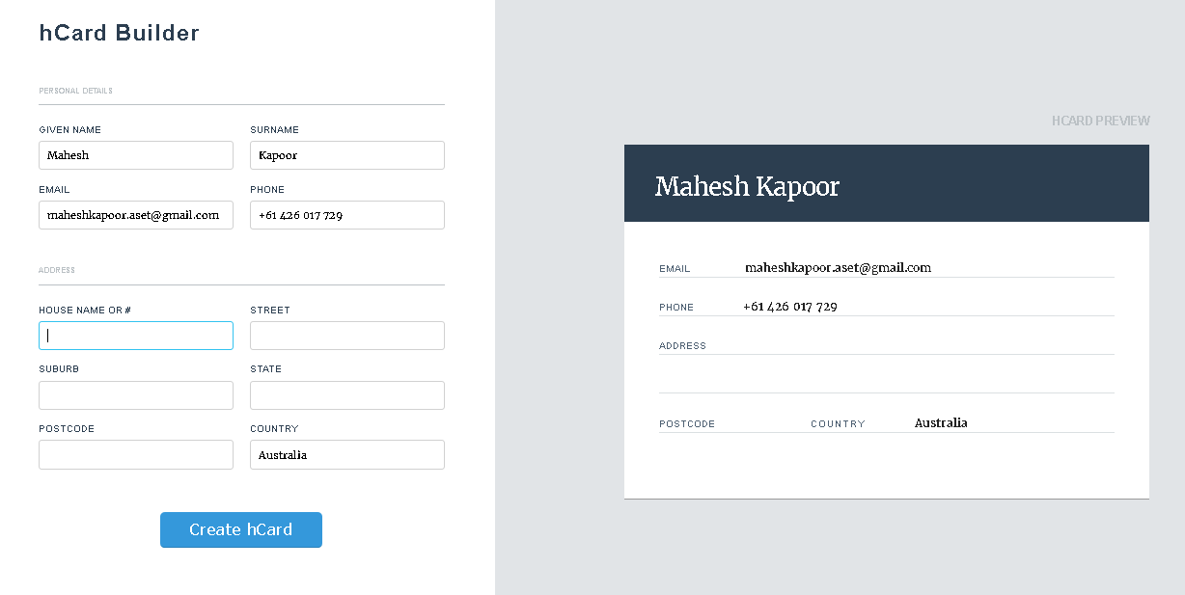

1. Submit button Action:

